# “A STUDY ON EFFECTIVENESS OF PERSONALIZED LEARNING WITH SPECIAL REFERENCE TO KANJIRAKADANS ACADEMY”

**PROJECT REPORT**

A project report submitted in partial fulfilment of the requirements for award of BBA degree [CBCS] by the Mahatma Gandhi University

**BACHELOR OF BUSINESS ADMINISTRATION**

**Submitted by, ANGEL ELICE MATHEW**

**(Register No:220021076695) Under The Guidance Of**

**Mrs. ANUMOL JOSEPH**

**(HOD, Department of Business Administration)**



**DEPARTMENT OF BUSINESS ADMINISTRATION MES COLLEGE ERUMELY**

**MARCH 2025**

MES COLLEGE ERUMELY

*(Affiliated to Mahatma Gandhi University, Kottayam, Kerala)*

**Propose P.O., Erumely, Kottayam District Kerala State 686509**



**DEPARTMENT OF BUSINESS ADMINISTRATION**

**CERTIFICATE**

This is to certify that this project report entitled “**A STUDY ON EFFECTIVENESS OF PERSONALIZED LEARNING WITH SPECIAL REFERENCE TO**

**KANJIRAKADANS ACADEMY, KOTTAYAM”** has been submitted by **Ms. Angel Elice Mathew (220021076695)** in partial fulfilment of requirement for the award of BBA Degree (CBCS) by the Mahatma Gandhi University, Kottayam during the academic year 2024-2025

**Mrs. ANUMOL JOSEPH Mrs. ANUMOL JOSEPH**

**Project Guide Head of The Department**

**Submitted for the examination on ....................................................**

**Internal Examiner External Examiner**

**DECLARATION**

I **ANGEL ELICE MATHEW (Reg No:220021076711)** hereby declare that the project report entitled **“A STUDY ON EFFECTIVENESS OF PERSONALIZED LEARNING WITH SPECIAL REFERENCE TO KANJIRAKADANS**

**ACADEMY, KOTTAYAM”** has been prepared by me under the guidance and supervision of Mrs. ANUMOL JOSEPH, Head of The Department, MES College, Erumely and submitted to Mahatma Gandhi University, in a partial fulfilment of the requirements for the award of the degree of Bachelor of Business Administration.

### Place: ERUMELY ANGEL ELICE MATHEW Date: REG NO: 220021076695

**ACKNOWLEDGEMENT**

First of all, I thank God Almighty for enabling me to complete this study successfully and also my parents to their valuable support.

I express my sincere gratitude to Prof. (Dr) **ANILKUMAR S**, principal MES College, Erumely for providing a golden opportunity to do research in a reputed organization.

I take privilege in acknowledging **Mrs. ANUMOL JOSEPH**, HOD of the Department of Management Studies, for her valuable guidance and prompt correspondence.

I express my profound gratitude to faculty guide **Mrs. ANUMOL JOSEPH** for her constant guidance and encouragement throughout the research.

Finally, I would like to express our grateful thanks to the respondents for their good co- operation for completion of this project.

## PLACE: ERUMELY ANGEL ELICE MATHEW DATE: REG NO:220021076695

**TABLE OF CONTENTS**

|  |  |  |
| --- | --- | --- |
| **CHAPTERS** | **TITLE** | **PAGE NO:** |
|  | SYNOPSIS |  |
|  | LIST OF TABLES |  |
|  | LIST OF FIGURES |  |
| **CHAPTER 1** | **INTRODUCTION** | **1 - 11** |
| 1.1 | INTRODUCTION TO THE TOPIC | 1 – 3 |
| 1.2 | INDUSTRY PROFILE | 4 - 6 |
| 1.3 | COMPANY PROFILE | 7 – 9 |
| 1.4 | SCOPE OF THE STUDY | 10 |
| 1.5 | OBJECTIVES | 11 |
| **CHAPTER 2** | **DESIGN OF THE STUDY** | **12 – 15** |
| 2.1 | RESEARCH METHODOLOGY | 12 |
| 2.2 | RESEARCH DESIGN | 12 |
| 2.3 | SOURCES OF DATA | 13 |
| 2.4 | SAMPLE DESIGN | 13 |
| 2.5 | DATA ANALYSIS TOOLS AND TECHNIQUES | 14 |
| 2.6 | LIMITATIONS OF THE STUDY | 15 |
| **CHAPTER 3** | **DATA ANALYSIS TOOLS AND INTERPRETATION** | **16 – 73** |
| **CHAPTER 4** | **RESULTS** | **74 - 81** |
|  | FINDINGS | 74 |
|  | SUGGESTIONS | 75 |
|  | CONCLUSIONS | 76 |
|  | BIBILOGRAPHY | 77 |
|  | ANNEXURE | 78 - 81 |

**SYNOPSIS**

This study examines the impact of personalized learning at Kanjirakadans Academy, focusing on its effectiveness in improving student performance and addressing individual learning needs. It evaluates the role of education networks, identifies factors influencing the selection of educational institutions, and explores challenges in implementing personalized learning models. The study aims to contribute to the development of effective strategies for enhancing personalized learning in educational institutions. By analysing these aspects, the study aims to provide a comprehensive understanding of the benefits and barriers of personalized learning.

**LIST OF TABLES**

|  |  |  |
| --- | --- | --- |
| **NO. OF TABLES** | **TITLE** | **PAGE.NO** |
| 3.1 | Gender wise classification of respondents | 16 |
| 3.2 | Age wise classification of respondents | 18 |
| 3.3 | Educational status of respondents | 20 |
| 3.4 | Income wise classification of respondents | 22 |
| 3.5 | Usage of educational network | 24 |
| 3.6 | Satisfaction with educational network | 26 |
| 3.7 | Most used educational network | 28 |
| 3.8 | Most valuable feature of educational network | 30 |
| 3.9 | Educational network vs traditional learning | 32 |
| 3.10 | Comparing engagement in personalised and traditional learning | 34 |
| 3.11 | Grasping topics in personalized learning | 36 |
| 3.12 | Personalized learning & exam performance | 38 |
| 3.13 | Impact of personalized learning on academic stress | 40 |
| 3.14 | Frequency of personalized learning support | 42 |
| 3.15 | Receiving enough individual attention in personalized sessions | 44 |
| 3.16 | Learning pace at academy | 46 |
| 3.17 | Personalised learning recommendation | 48 |
| 3.18 | Kanjirakadans academy vs traditional methods in supporting individual needs | 50 |
| 3.19 | Personalized learning in overcoming difficult subjects | 52 |
| 3.2 | Influence of fee structure on selection | 54 |
| 3.21 | Importance of location | 56 |
| 3.22 | Significance in faculty expertise | 58 |
| 3.23 | Influence of personalised learning options on institution choice | 60 |
| 3.24 | Factors influence in choosing the academy | 62 |
| 3.25 | Technical challenges in personalised learning sessions | 64 |
| 3.26 | Lack of clear guidance in personalized learning sessions | 66 |
| 3.27 | Insufficient instructor feedback in personalised learning | 68 |
| 3.28 | Workload comparison | 70 |
| 3.29 | Difficulty in balancing commitments | 72 |

**LIST OF FIGURES**

|  |  |  |
| --- | --- | --- |
| **NO. OF TABLES** | **TITLE** | **PAGE.NO** |
| 3.1 | Gender wise classification of respondents | 17 |
| 3.2 | Age wise classification of respondents | 19 |
| 3.3 | Educational status of respondents | 21 |
| 3.4 | Income wise classification of respondents | 23 |
| 3.5 | Usage of educational network | 25 |
| 3.6 | Satisfaction with educational network | 27 |
| 3.7 | Most used educational network | 29 |
| 3.8 | Most valuable feature of educational network | 31 |
| 3.9 | Educational network vs traditional learning | 33 |
| 3.10 | Comparing engagement in personalised and traditional learning | 35 |
| 3.11 | Grasping topics in personalized learning | 37 |
| 3.12 | Personalized learning & exam performance | 39 |
| 3.13 | Impact of personalized learning on academic stress | 41 |
| 3.14 | Frequency of personalized learning support | 43 |
| 3.15 | Receiving enough individual attention in personalized sessions | 45 |
| 3.16 | Learning pace at academy | 47 |
| 3.17 | Personalised learning recommendation | 49 |
| 3.18 | Kanjirakadans academy vs traditional methods in supporting individual needs | 51 |
| 3.19 | Personalized learning in overcoming difficult subjects | 53 |
| 3.2 | Influence of fee structure on selection | 55 |
| 3.21 | Importance of location | 57 |
| 3.22 | Significance in faculty expertise | 59 |
| 3.23 | Influence of personalised learning options on institution choice | 61 |
| 3.24 | Factors influence in choosing the academy | 63 |
| 3.25 | Technical challenges in personalised learning sessions | 65 |
| 3.26 | Lack of clear guidance in personalized learning sessions | 67 |
| 3.27 | Insufficient instructor feedback in personalised learning | 69 |
| 3.28 | Workload comparison | 71 |
| 3.29 | Difficulty in balancing commitments | 73 |

# CHAPTER–1 INRODUCTION

* 1. **INTRODUCTION TO THE TOPIC**

## PERSONALIZED LEARNING

Personalized learning is an educational approach designed to cater to the unique needs, preferences, and goals of each individual learner. It recognizes that every student has a distinct way of learning, progressing at different paces and possessing varied strengths, challenges, and interests. The objective of personalized learning is to create a tailored learning experience that maximizes the potential of every learner. It recognizes that every learner is unique and aims to provide customized learning experiences to help them progress at their own pace and in a way that best suits their abilities. This method allows for flexibility in how students access content, how they engage with it, and how they demonstrate their learning

### Key features of personalized learning include:

* + 1. **Learner-Centric Approach**: Focus on the learner’s needs, allowing them to take ownership of their educational journey.
    2. **Flexible Pace**: Students progress at their own speed, spending more time on challenging concepts while moving quickly through topics they grasp easily.
    3. **Customized Content**: Educational material and activities are aligned with the learner’s interests, career goals, and learning style.
    4. **Use of Technology**: Digital tools and platforms enable adaptive learning, providing real-time feedback and resources tailored to the learner’s progress.
    5. Collaborative Role of Educators: Teachers act as facilitators, mentors, and guides, designing and monitoring individualized learning plans.

### Key elements of personalized learning include:

1. **Pacing**: Students can move through content at their own speed, taking more time on challenging topics and advancing faster through areas they grasp quickly.
2. **Learning Pathways**: The curriculum can be adjusted to match students' strengths, interests, and goals, providing different resources, activities, and assessments.
3. **Assessment**: Ongoing assessments help to monitor student progress and adjust learning plans accordingly, ensuring that each student receives the support they need.
4. **Learner Control**: Students have more autonomy in their learning, often setting their own goals and making decisions about the tools or resources they use.

Overall, personalized learning aims to maximize each student’s potential by addressing their unique educational needs and empowering them to take ownership of their learning process.

## EFFECTIVENESS OF PERSONALIZED LEARNING

The effectiveness of personalized learning in education is widely recognized for its potential to improve student outcomes by catering to individual needs, preferences, and learning styles. Here are some key ways in which personalized learning proves effective:

1. **Improved Student Performance:** Personalized learning allows students to progress at their own pace, ensuring that they master concepts before moving on to more advanced topics. This approach helps to address gaps in understanding, particularly for struggling students, leading to improved academic performance.
2. **Greater Engagement and Motivation**: When students have control over their learning, they are more likely to feel invested in the process. Moreover, when students work at their own pace and see progress, they feel more motivated to continue learning, reducing the likelihood of disengagement or dropout.
3. **Support for Diverse Learning Needs**: Personalized learning supports a diverse range of learning needs by providing differentiated instruction. It is particularly effective for students with different abilities, including those with learning disabilities, gifted students, or English language learners.
4. **Development of Critical Skills**: Personalized learning emphasizes the development of key skills such as critical thinking, problem-solving, self- regulation, and independent learning These skills are crucial for success in both academic settings and the real world.
5. **Better Teacher-Student Interaction**: With personalized learning, teachers have more opportunities to interact with students on an individual level. This can lead to stronger teacher-student relationships, as teachers gain a deeper understanding of each student’s strengths, challenges, and learning preferences.
6. **Flexibility and Adaptability**: Personalized learning adapts to the needs and abilities of each student, offering them the flexibility to work at their own pace. Some students may need more time to master a concept, while others may move ahead more quickly.
7. **Promotes Lifelong Learning**: By encouraging students to take ownership of their learning, personalized education fosters an attitude of lifelong learning. Students develop skills such as goal-setting, time management, and self- reflection that can serve them well beyond the classroom. They also learn how to

navigate challenges and seek resources to solve problems, which prepares them for continuous learning throughout their lives.

1. **Inclusive Education**: Personalized learning can contribute to more inclusive educational practices by providing a range of resources and support for students with varying needs. By customizing instruction and materials, personalized learning helps ensure that all students, regardless of their starting point, can participate fully in their education.

## IMPORTANCE OF PERSONALIZED LEARNING

Personalized learning is becoming increasingly important in modern education due to its potential to enhance student engagement, achievement, and overall learning experiences. Here are the key reasons why personalized learning is important:

* 1. **Meets Individual Learning Needs:** Personalized learning tailors the educational experience to the unique needs, abilities, and interests of each student.
  2. **Enhances Student Engagement:** When students have more control over their learning paths, they are more likely to be motivated and actively engaged.
  3. **Improves Academic Achievement**: Personalized learning allows students to progress at their own pace, ensuring they fully understand concepts before moving on to more advanced topics.
  4. **Builds Critical Thinking and Problem-Solving Skills**: Many personalized learning approaches involve project-based or inquiry-based learning, which encourages students to think critically, analyse information, and solve complex problems.
  5. **Promotes Equity in Education:** Personalized learning can help bridge the achievement gap by providing tailored support to students who may otherwise be left behind.

The importance of personalized learning lies in its ability to create a more inclusive, engaging, and effective educational experience. By addressing the unique needs of each student, it enhances academic outcomes, fosters independence, and equips students with the skills they need for future success. Personalized learning not only benefits individual students but also contributes to a more equitable and adaptive educational system as a whole.

* 1. **INDUSTRY PROFILE EDUCATION**

Education is the transmission of knowledge, skills, and character traits. There are many types of education. Formal education happens in a complex institutional framework, like public schools. Non-formal education is also structured but takes place outside the formal schooling system. Informal education is unstructured learning through daily experiences. Formal and non-formal education are divided into levels. They include early childhood education, primary education, secondary education, and tertiary education. Other classifications focus on the teaching method, like teacher-centered and student-centered education. Forms of education can also be distinguished by subject, like science education, language education, and physical education. The term "education" can also refer to the mental states and qualities of educated people and the academic field studying educational phenomena.

Many factors influence whether education is successful. Psychological factors include motivation, intelligence, and personality. Social factors, like socioeconomic status, ethnicity, and gender, are often linked to discrimination. Further factors include access to educational technology, teacher quality, and parent involvement.

## KEY SEGMENTS IN EDUCATION INDUSTRY

* + 1. **Pre-School Education**: Focuses on the early development of children before formal schooling, including daycare, early childhood education centers, and preschools.
    2. **Primary and Secondary Education:** Involves K-12 education (kindergarten through grade 12), which includes both public and private schools.
    3. **Higher Education:** Comprises colleges, universities, and vocational institutions offering undergraduate, graduate, and doctoral programs.
    4. **Vocational and Technical Education:** Provides specialized training for specific careers or trades, such as nursing, plumbing, and IT.
    5. **Online and Distance Education:** Includes online courses, degrees, and certifications offered through digital platforms, which have gained significant traction due to their flexibility and accessibility.
    6. **Corporate and Adult Education**: Focuses on adult learners seeking skill development, certifications, or continued education, often in the form of workshops, professional training, or executive education programs.

## KEY DRIVERS OF EDUCATION INDUSTRY

1. **Technology Integration**: The rise of edtech has revolutionized the education industry with innovations such as online learning platforms, digital classrooms, gamification, and AI-powered learning tools.
2. **Globalization**: Education systems are increasingly interconnected. Many students pursue higher education abroad, and institutions offer courses that are internationally recognized.
3. **Personalized Learning**: There is a growing shift towards tailored learning experiences, supported by data analytics and AI, to meet the diverse needs of students.
4. **Lifelong Learning**: With the rapid pace of technological change, continuous learning is now seen as essential for career advancement. This is encouraging the growth of online courses, certifications, and micro credentials.
5. **Regulatory Changes**: Governments across the world are making reforms to improve educational outcomes, increase access, and ensure the quality of education.

## EMERGING TRENDS IN EDUCATION

1. **EdTech Boom**: Educational technology companies are rapidly expanding, offering tools that range from online learning platforms to virtual classrooms, eBooks, and AI tutors.
2. **Hybrid Learning Models**: A combination of in-person and online education that offers flexibility to both students and teachers, especially post-COVID.
3. **Gamification**: The integration of game-like elements (such as scoring, competitions, and rewards) into the learning process to make education more engaging and motivating for students.
4. **Artificial Intelligence (AI) and Data Analytics**: AI is being used to personalize learning experiences, assess student progress, and provide targeted interventions. Data analytics help educators monitor learning patterns and outcomes.
5. **Social and Emotional Learning (SEL)**: There is a growing emphasis on the development of emotional intelligence, resilience, and interpersonal skills alongside traditional academic achievements.
6. **Sustainability and Green Education**: Educational institutions are incorporating sustainability into curricula, and there is a growing focus on

teaching students about climate change, conservation, and environmental protection.

## CHALLENGES FACING IN EDUCATION INDUSTRY

1. **Access and Equity**: Despite significant advances, there are still disparities in access to quality education, particularly in low-income regions or communities with marginalized groups.
2. **Digital Divide**: Not all students have equal access to technology or the internet, which can exacerbate inequalities in education, particularly in remote or underserved areas.
3. **Teacher Training and Support**: Teachers need ongoing professional development to effectively integrate technology and adapt to changing teaching methods. Additionally, teacher shortages in certain regions or subjects remain a challenge.
4. **Quality and Standardization**: Ensuring that educational programs, both traditional and online, maintain high standards and provide quality learning experiences is critical. There are concerns about the credentialing and certification process, especially with the rise of non-traditional education models.
5. **Mental Health and Well-being**: Increasing pressures on students, especially in competitive academic environments, have raised concerns about mental health issues such as stress, anxiety, and burnout.
   1. **COMPANY PROFILE**

Kanjirakadans Academy, a leading educational institution based in Thirunakkara, Kottayam, with branches in Kanjikuzhi, Kottayam, and Kattappana, Idukki offers a dynamic approach to language mastery, blending individualized attention with flexible learning options. The academy’s diverse programs cater to a wide range of learners, from professionals to students and homemakers. With specialized courses in IELTS, OET, PTE, CBT, German, and Spoken English, students can expect a holistic educational experience that includes online and offline learning, personalized mentoring, study materials, listening labs, and mock exams.

The academy’s focus on “Goal, Guidance, Growth” ensures that students receive the support they need to overcome challenges and achieve their language learning aspirations. Whether you are just beginning your journey or aiming to accelerate your progress, Kanjirakadans Academy offers courses that meet your specific needs and pace. With a vision to inspire confidence, creativity, and growth, the academy serves as a nurturing environment for all who are determined to master their language skills and unlock new opportunities.

Their mission is to empower individuals by unlocking your linguistic potential. Whether you're a professional looking to advance your career, a student preparing for exams, or a homemaker enhancing communication skills, they provide personalized coaching that fosters both growth and confidence.

### Key Highlights:

* **Tailored Coaching**: We offer both offline and online classes with a focus on one-on-one attention. Our expert mentors provide personalized guidance to help students achieve their goals.
* **State-of-the-Art Facilities**: Our academy features cutting-edge study materials, a listening lab, and a robust mock exam schedule to enhance learning experiences.
* **Flexible Learning Options**: Courses are designed to accommodate learners of all levels, from beginners to advanced students. We offer flexible durations, allowing students to choose the pace that suits their needs.
* **Comprehensive Approach**: Beyond teaching languages, we emphasize overcoming individual challenges, helping students refine their skills and conquer obstacles to success.

At Kanjirakadans Academy, they believe in the power of Goal, Guidance, and Growth. They are committed to providing unwavering support throughout your learning journey, helping you achieve your dreams and unlock new opportunities.

## MISSION

We aim to equip learners with the English language proficiency that they require in their respective fields and on various eligibility tests.

## VISION

To build a generation that handles the English language effortlessly and fluently with confidence and paves the way to conquering heights.

## METHODOLOGY

Our learner-centric methodology ensures regular evaluation that thoroughly monitors the progress of students and makes them capable of self-assessing their level of achievement.

**USP**

### Commitment To Candidate

Kanjirakadans Academy assures the best learning experience by providing individual attention, a student's friendly atmosphere, and a highly developed feedback system.

### Proactive Problem Solving

Our dedicated staff and feedback system endeavour to detect and solve the problems that may be faced by students in their learning atmosphere.

### Result Oriented Training Sessions

Our nano batches aim to give proper scaffolding for students in their respective weak areas. Training sessions are target-oriented and helpful to upgrade the scores of individual modules.

### Attitude And Ethics

Educate to serve" is the key principle in which the institution abides. Meticulously planned teaching methods, trained and dedicated tutors, friendly atmosphere, and updated feedback system are the characteristic features we ensure.

### Well Planned and Focused

Our Academy provides well-developed study materials prepared by an expert team of qualified and experienced staff. We follow the learner-centred method of teaching.

### Well Planned and Focused

Kanjirakadans Academy makes sure daily individual corrections and conducts weekly mock tests in order to assess the achievement level of the learner.

**OFFERINGS**

### Free Demo Class

Experience the first step in language mastery with a free trial class.

### Nano Batches

Experience personalized learning with our nano batches – small groups, big progress.

### Online & Classroom

Seamless learning options with the flexibility of both online and classroom coaching

**COURSES OFFERING**

* IELTS
* UKVI
* OET
* PTE
* German
* Spoken English
  1. **SCOPE OF THE STUDY**

This study focuses on understanding the effectiveness of personalized learning models adopted by Kanjirakadans Academy. It aims to evaluate how personalized strategies impact students’ academic and personal development, while also identifying the barriers that institutions face in the adoption and execution of such models. The study will also provide valuable insights for educators, administrators, and policymakers. It will help in understanding the role of personalized learning in modern education and offer recommendations to improve its implementation, thereby benefiting students, teachers, and institutions alike.

* 1. **OBJECTIVES OF THE STUDY**
* To check whether the education networks are effective or not.
* To assess how personalized learning improves student performance.
* To study how personalized learning supports individual learning needs.
* To identity the factors influence in selection of education institution.
* To study challenges faced in implementing personalized learning models.

# CHAPTER 2 DESIGN OF THE STUDY

* 1. **RESEARCH METHODOLOGY**

Research methodology is a way to systematically solve the research problem. It may be understood as a science of studying how research is done scientifically. In it we study the various steps that are generally adopted by a researcher in studying his research problem along with the logic behind them. It is necessary for the researcher to know not only the research methods/techniques but also the methodology. Researchers not only need to know how to develop certain indices or tests, how to calculate the mean, the mode, the median or the standard deviation or chi-square, how to apply particular research techniques, but they also need to know which of these methods or techniques, are relevant and which are not, and what would they mean and indicate and why.

Researchers also need to understand the assumptions underlying various techniques and they need to know the criteria. By which they can decide that certain techniques and procedures will be applicable to certain problems and others will not. All this means that it is necessary for the researcher to design his methodology. For his problem as the same may differ from problem to problem

* 1. **RESEARCH DESIGN**

A research design is the arrangement of conditions for collection and analysis of data in a manner that aims to combine relevance to the research purpose with economy in procedure. In fact, the research design is the conceptual structure within which research is conducted; it constitutes the blueprint for the collection, measurement and analysis of data. Descriptive research design is used for this study.

**DESCRIPTIVE RESEARCH DESIGN**

Descriptive research design is a type of research design that aims to obtain information to systematically describe a phenomenon, situation, or population. It can answer what, where, when and how questions, but not why questions. A descriptive research design can use a wide variety of research methods to investigate one or more variables. There are three main types of descriptive methods: observational methods, case-study methods and survey methods. It is a fact-finding investigation with adequate interpretation. It enumerates data about the population being studied. It is a type of research data collected by one or more appropriate methods such as observation method, interview method, mailed questionnaire method, etc.

* 1. **SOURCES OF DATA**

The data was collected mainly through two sources namely, Primary data and secondary data. Primary data are those collected by the researcher himself for the first time and they are original. In this study, the primary data were collected by making field surveys with questionnaires. This is an important and very popular method of data collection. A questionnaire is a printed list of questions relating to the various aspects, the data were collected by supplying questionnaire. Secondary data means the data already available that is, the data which have already been collected and analysed by someone else. In this study the secondary data are collected from books, internet etc.

* 1. **SAMPLING DESIGN**

A sample design is a definite plan for obtaining a sample from a given population. It refers to the technique or the procedure the researcher would adopt in selecting items for the sample. Sample design may as well lay down the number of items to be included in the sample. Sample design is determined before data are collected. There are many sample designs from which a researcher can choose. In this study convenience sampling is used.

**CONVENIENCE SAMPLING**

Convenience sampling is a specific type of non-probability sampling method that relies on data collection from population members who are conveniently available to participate in study. Convenience sampling is a type of sampling where the first available primary data source will be used for the research without additional requirements.

**POPULATION**

Universe or population is the aggregate of all the units to be studied in any field of enquiry. Number of students in Kanjirakadans Academy is considered as the population for the study.

**SAMPLE SIZE**

In research terms, a sample is a group of people, objects, or items that are taken from a larger population for measurement. The sample should be representative of the population to ensure that we can generalize the findings from the research sample to the population as a whole. The sample selected for this study is from 100 students

* 1. **DATA ANALYSIS TOOLS AND TECHNIQUES**

The information collected through the questionnaire was analysed and tabulated by using Average and Percentage.

**Percentage = No of respondents / Total no. of respondents×100**

* 1. **LIMITATION OF THE STUDY**
     + Some information cannot be accessed due to its confidential nature.
     + The respondents are less interested in answering the questionnaire, as it is an interruption to their regular study.
     + Time is a major limitation in completing those studies. The period was limited for only one month.
     + The study is focused on a specific location or context

# CHAPTER 3

**DATA ANALYSIS AND INTERPRETATION**

**TABLE 3.1**

**GENDER WISE CLASSIFICATION**

|  |  |  |
| --- | --- | --- |
| **RESPONSE** | **NO. OF RESPONDENTS** | **PERCENTAGE** |
| MALE | 52 | 52 |
| FEMALE | 48 | 48 |
| OTHERS | 0 | 0 |
| **TOTAL** | **100** | **100** |

**INTERPRETATION:**

The above table shows that majority of the respondents are male 52% & remaining 48% are females.

**FIGURE 3.1**

**GENDER WISE CLASSIFICATION**

NO. OF RESPONDENTS

|  |  |  |  |
| --- | --- | --- | --- |
| 60 |  | | |
| 50 |  |  |  |
| 40 |  |  |  |
| 30 |  |  |  |
| 20 |  |  |  |
| 10 |  |  |  |
| 0 | MALE | FEMALE | OTHERS |

**TABLE 3.2**

**AGE WISE CLASSIFICATION**

|  |  |  |
| --- | --- | --- |
| **RESPONSES** | **NO. OF RESPONDENTS** | **PERCENTAGE** |
| 15-20 | 12 | 12 |
| 20-25 | 39 | 39 |
| 25-30 | 22 | 22 |
| 30 ABOVE | 27 | 27 |
| **TOTAL** | **100** | **100** |

**INTERPRETATION:**

The above table shows that 39% of the respondents are in the age group between 20-25, age group above 30 are of 27%, 22% of respondents are in the age group of 25-30 & 12% of respondents are in the age group of 15-20

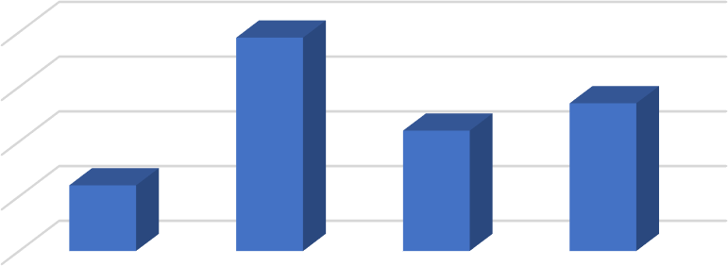

NO. OF RESPONDENTS

40

30

20

10

0

15-20

20-25

25-30

30 ABOVE

**FIGURE 3.2**

**AGE WISE CLASSIFICATION**

**TABLE 3.3**

**EDUCATIONAL STATUS OF RESPONDENTS**

|  |  |  |
| --- | --- | --- |
| **RESPONSE** | **NO. OF RESPONDENTS** | **PERCENTAGE** |
| 10TH GRADE | 6 | 6 |
| 12TH GRADE | 28 | 28 |
| UNDER GRADUATE | 44 | 44 |
| POST GRADUATE | 22 | 22 |
| **TOTAL** | **100** | **100** |

**INTERPRETATION:**

The above table shows that 44% of respondents are undergraduate students, 28% of respondents are 12th grade students, 22% of respondents are post graduate students & 6% of respondents are 10th grade students

**FIGURE 3.3**

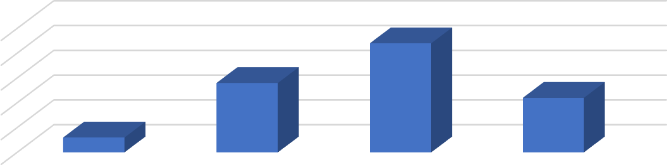**EDUCATIONAL STATUS OF RESPONDENTS**

NO. OF RESPONDENTS

|  |  |  |  |  |
| --- | --- | --- | --- | --- |
| 50 |  | | | |
| 40 |  |  |  |  |
| 30 |  |  |  |  |
| 20 |  |  |  |  |
| 10 |  |  |  |  |
| 0 | 10TH GRADE | 12TH GRADE | UNDER GRADUATE | POST GRADUATE |

**TABLE 3.4**

**INCOME WISE CLASSIFICATION OF RESPONDENTS**

|  |  |  |
| --- | --- | --- |
| **RESPONSE** | **NO. OF RESPONDENTS** | **PERCENTAGE** |
| BELOW 25000 | 5 | 5 |
| 25000-35000 | 34 | 34 |
| 35000-45000 | 42 | 42 |
| 45000 ABOVE | 19 | 19 |
| **TOTAL** | **100** | **100** |

**INTERPRETATION:**

The above table shows that 42% of respondent’s family income is in the range between 35000-45000, 34% of respondents is 25000-35000, 19% of respondents is above 45000 & 5% of respondents is below 25000.

|  |  |
| --- | --- |
| **FIGURE 3.4**  **INCOME WISE CLASSIFICATION OF RESPONDENTS** | |
|  | NO. OF RESPONDENTS  50  40  30  20  10  0  BELOW 25000 25000-35000 35000-45000 45000 ABOVE |
|  | |

**TABLE 3.5**

**USAGE OF EDUCATIONAL NETWORKS**

|  |  |  |
| --- | --- | --- |
| **RESPONSE** | **NO. OF RESPONDENTS** | **PERCENTAGE** |
| DAILY | 14 | 14 |
| WEEKLY | 29 | 29 |
| OCCASIONALLY | 47 | 47 |
| RARELY | 10 | 10 |
| **TOTAL** | **100** | **100** |

**INTERPRETATION:**

The above table shows that 47% of respondents use educational networks for learning purposes occasionally, 29% use them on a weekly basis, 14% use them daily, & 10% use them only rarely

**FIGURE 3.5**

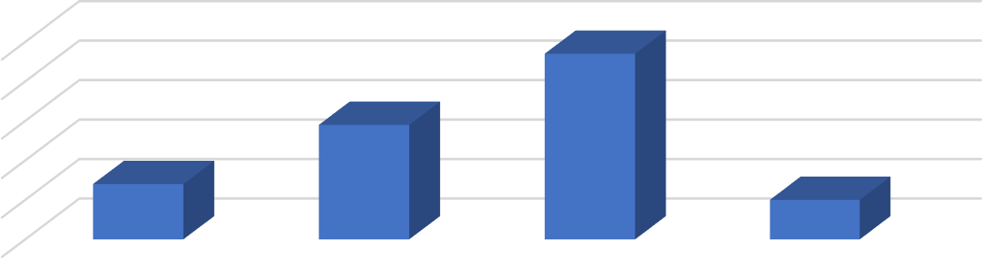**USAGE OF EDUCATIONAL NETWORKS**

NO.OF RESPONDENTS

|  |  |  |  |  |
| --- | --- | --- | --- | --- |
| 50 |  | | | |
| 40 |  |  |  |  |
| 30 |  |  |  |  |
| 20 |  |  |  |  |
| 10 |  |  |  |  |
| 0 | DAILY | WEEKLY | OCCASIONALLY | RARELY |

**TABLE 3.6**

**SATISFACTION WITH EDUCATIONAL NETWORK**

|  |  |  |
| --- | --- | --- |
| **RESPONSES** | **NO OF RESPONDENTS** | **PERCENTAGE** |
| VERY SATISFIED | 41 | 41 |
| NEUTRAL | 44 | 44 |
| DISSATISFIED | 15 | 15 |
| **TOTAL** | **100** | **100** |

**INTERPRETATION:**

The above table shows that 44% of respondents are neutrally satisfied with the resources provided by the educational networks, 41% of respondents are very satisfied & 15% of respondents are dissatisfied

|  |  |
| --- | --- |
| **FIGURE 3.6**  **SATISFACTION WITH EDUCATIONAL NETWORK** | |
|  | NO OF RESPONDENTS  50  40  30  20  10  0  VERY SATISFIED NEUTRAL DISSATISFIED |
|  | |

**TABLE 3.7**

**MOST USED EDUCATIONAL NETWORK**

|  |  |  |
| --- | --- | --- |
| **RESPONSES** | **NO. OF RESPONDENTS** | **PERCENTAGE** |
| TOUTUBE | 17 | 17 |
| SEARCH ENGINES | 29 | 29 |
| SPECIALISED LEARNING WEBSITES | 35 | 35 |
| AI TOOLS | 19 | 19 |
| **TOTAL** | **100** | **100** |

**INTERPRETATION:**

The above table shows that 35% of respondents’ most frequently used education network for personalised learning is specialised learning websites, 29% are search engines, 19% are AI tools & 17% are YouTube.

|  |  |
| --- | --- |
| **FIGURE 3.7**  **MOST USED EDUCATIONAL NETWORK** | |
|  | NO. OF RESPONDENTS  40  30  20  10  0  TOUTUBE SEARCH ENGINES SPECIALISED AI TOOLS  LEARNING WEBSITES |
|  | |

**TABLE 3.8**

**MOST VALUABLE FEATURE OF EDUCATIONAL NETWORK**

|  |  |  |
| --- | --- | --- |
| **RESPONSES** | **NO OF RESPONDENTS** | **PERCENTAGE** |
| VIDEO TUTORIALS | 21 | 21 |
| SEARCH ENGINES | 35 | 35 |
| AI-GENERATED RESPONSES | 37 | 37 |
| INTERACTIVE LEARNING TOOLS | 7 | 7 |
| **TOTAL** | **100** | **100** |

**INTERPRETATION:**

The above table shows that 37% of respondents consider AI-generated responses to be the most valuable feature of educational networks for personalized learning, 35% value search engines like Google, 21% prefer video tutorials, and 7% prioritize interactive learning tools.

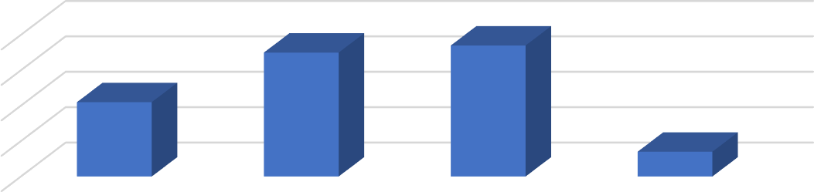

NO OF RESPONDENTS

40

30

20

10

0

VIDEO TUTORIALS

SEARCH ENGINES

AI-GENERATED

RESPONSES

INTERACTIVE

LEARNING TOOLS

**FIGURE 3.8**

**MOST VALUABLE FEATURE OF EDUCATIONAL NETWORK**

**TABLE 3.9**

**EDUCATIONAL NETWORKS VS TRADITIONAL CLASSROOM METHODS**

|  |  |  |
| --- | --- | --- |
| **RESPONSES** | **NO OF RESPONDENTS** | **PERCENTAGE** |
| YES | 56 | 56 |
| NO | 44 | 44 |
| **TOTAL** | **100** | **100** |

## INTERPRETATION:

The above table shows that 56% of respondents prefer learning through educational networks compared to traditional classroom methods while 44% of respondents does not.

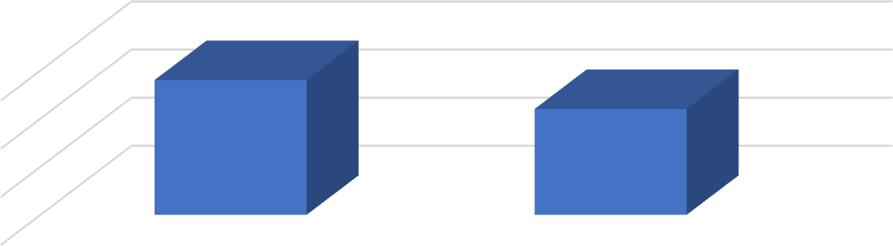

NO OF RESPONDENTS

60

40

20

0

YES

NO

**FIGURE 3.9**

**EDUCATIONAL NETWORKS VS TRADITIONAL CLASSROOM METHODS**

**TABLE 3.10**

**COMPARING ENGAGEMENT IN PERSONALIZED AND TRADITIONAL LEARNING**

|  |  |  |
| --- | --- | --- |
| **RESPONSES** | **NO OF RESPONDENTS** | **PERCENTAGE** |
| YES | 57 | 57 |
| NO | 43 | 43 |
| **TOTAL** | **100** | **100** |

**INTERPRETATION:**

The above table shows 57% of respondents find that personalized learning sessions are more engaging than traditional classes while 44% does not.

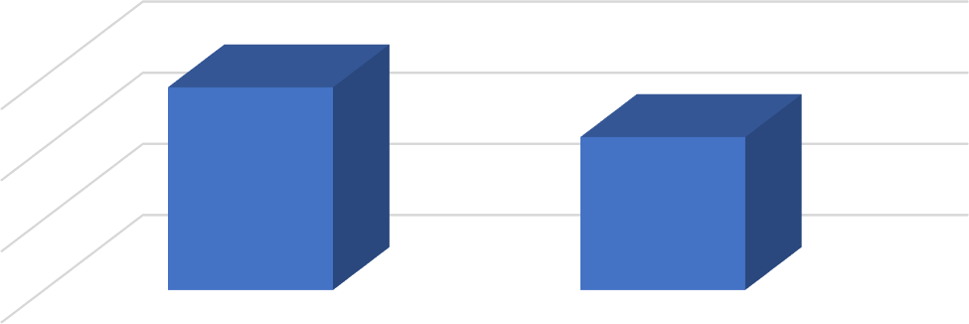

60

40

20

0

YES

NO

**FIGURE 3.10**

**COMPARING ENGAGEMENT IN PERSONALIZED AND TRADITIONAL LEARNING**

**TABLE 3.11**

**GRASPING TOPICS IN PERSONALIZED LEARNING**

|  |  |  |
| --- | --- | --- |
| **RESPONSES** | **NO OF RESPONDENTS** | **PERCENTAGE** |
| EXTREMELY WELL | 54 | 54 |
| NEUTRAL | 32 | 32 |
| NOT AT ALL | 14 | 14 |
| **TOTAL** | **100** | **100** |

**INTERPRETATION:**

The above table shows that 32% of respondents have a neutral understanding of topics after personalized learning, 54% have an excellent understanding, and 14% do not understand the topics.

**FIGURE 3.11**

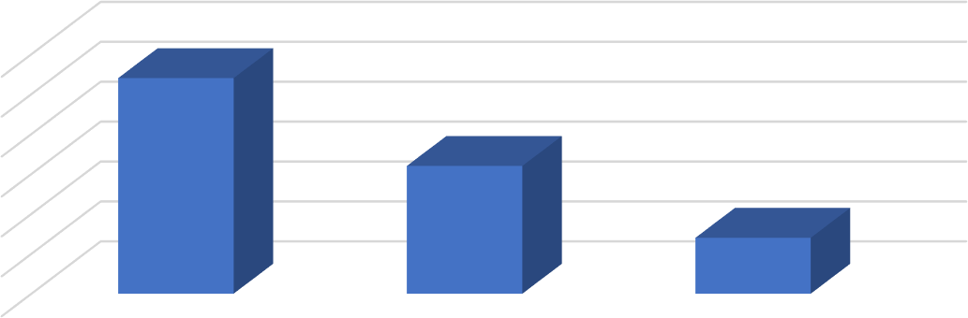**GRASPING TOPICS IN PERSONALIZED LEARNING**

NO OF RESPONDENTS

|  |  |  |  |
| --- | --- | --- | --- |
| 60 |  | | |
| 50 |  |  |  |
| 40 |  |  |  |
| 30 |  |  |  |
| 20 |  |  |  |
| 10 |  |  |  |
| 0 | EXTREMELY WELL | NEUTRAL | NOT AT ALL |

**TABLE 3.12**

**PERSONALIZED LEARNING AND EXAM PERFORMANCE**

|  |  |  |
| --- | --- | --- |
| **RESPONSES** | **NO. OF RESPONDENTS** | **PERCENTAGE** |
| YES | 68 | 68 |
| NO | 32 | 32 |
| **TOTAL** | **100** | **100** |

**INTERPRETATION:**

The above table shows that 68% of respondents believe personalized learning has improved their performance in exams while 32% do not.

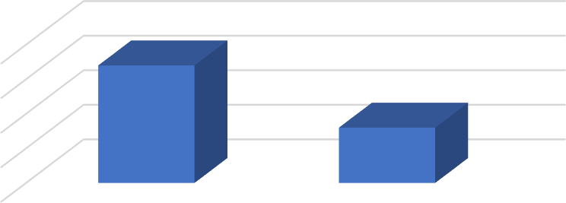

NO.OF RESPONSES

80

60

40

20

0

NO.OF RESPONSES

YES NO

**FIGURE 3.12**

**PERSONALIZED LEARNING AND EXAM PERFORMANCE**

**TABLE 3.13**

**IMPACT OF PERSONALIZED LEARNING ON ACADEMIC STRESS**

|  |  |  |
| --- | --- | --- |
| **RESPONSES** | **NO OF RESPONSES** | **PERCENTAGE** |
| YES | 56 | 56 |
| NO | 44 | 44 |
| **TOTAL** | **100** | **100** |

**INTERPRETATION:**

The above table shows that 56% of respondents believe personalized learning reduces academic stress while 44% disagree

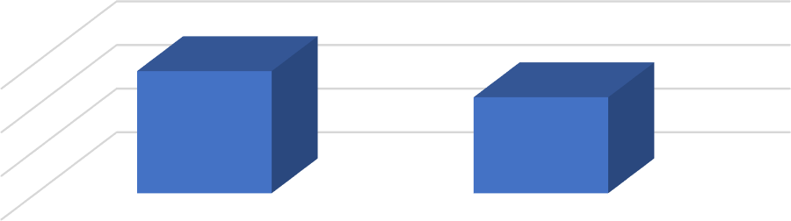

NO OF RESPONSES

60

40

20

0

YES

NO

**FIGURE 3.13**

**IMPACT OF PERSONALIZED LEARNING ON ACADEMIC STRESS**

**TABLE 3.14**

**FREQUENCY OF PERSONALIZED LEARNING SUPPORT AT KANJIRAKADANS ACADEMY**

|  |  |  |
| --- | --- | --- |
| **RESPONSES** | **NO. OF RESPONSES** | **PERCENTAGE** |
| ALWAYS | 44 | 44 |
| OFTEN | 35 | 35 |
| SOMETIMES | 16 | 16 |
| NEVER | 5 | 5 |
| **TOTAL** | **100** | **100** |

**INTERPRETATION:**

The above table shows that 44% of respondents always receive personalized learning support at Kanjirakadans Academy, 35% often receive it, 16% sometimes receive it, and 5% have never received it.

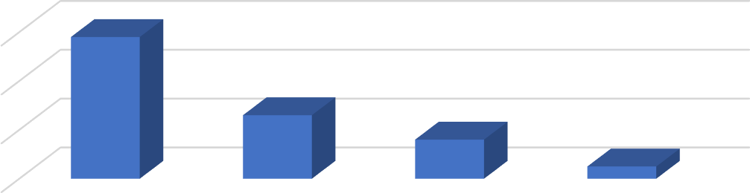

NO. OF RESPONSES

60

40

20

0

ALWAYS

OFTEN

SOMETIMES

NEVER

**FIGURE 3.14**

**FREQUENCY OF PERSONALIZED LEARNING SUPPORT AT KANJIRAKADANS ACADEMY**

**TABLE 3.15**

**RECEIVING ENOUGH INDIVIDUAL ATTENTION IN PERSONALIZED SESSIONS**

|  |  |  |
| --- | --- | --- |
| **RESPONSES** | **NO. OF RESPONDENTS** | **PERCENTAGE** |
| YES | 62 | 62 |
| NO | 32 | 32 |
| **TOTAL** | **100** | **100** |

**INTERPRETATION:**

The above table shows that 62% of respondents receive enough attention during personalized learning sessions & 46% does not.

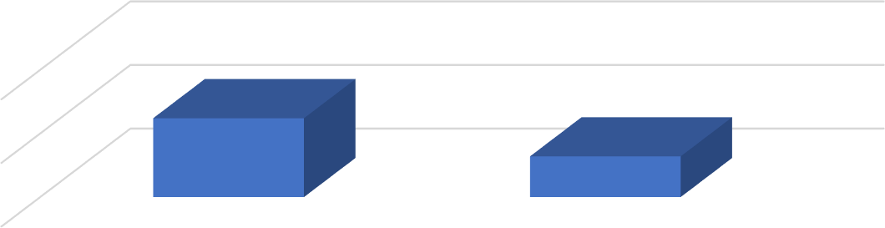

NO. OF RESPONDENTS

100

50

0

YES

NO

**FIGURE 3.15**

**RECEIVING ENOUGH INDIVIDUAL ATTENTION IN PERSONALIZED SESSIONS**

**TABLE 3.16 LEARNING PACE AT ACADEMY**

|  |  |  |
| --- | --- | --- |
| **RESPONSES** | **NO. OF RESPONSES** | **PERCENTAGE** |
| YES, IT IS PERFECT | 21 | 21 |
| IT’S MOSTLY GOOD | 50 | 50 |
| SOMETIMES IT’S TOO FAST OR SLOW | 24 | 24 |
| NO, IT DOES NOT SUIT MY NEEDS | 5 | 5 |
| **TOTAL** | **100** | **100** |

**INTERPRETATION:**

The above table shows that 51% of respondents feel the learning pace at Kanjirakadans Academy is mostly good in meeting their needs, 24% believe it is either too fast or too slow, 21% find it perfect, and 5% feel it does not meet their needs.

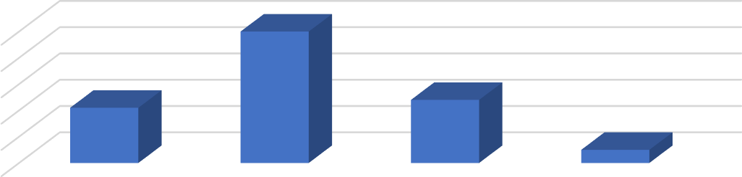

NO. OF RESPONSES

50

40

30

20

10

0

YES, IT IS PERFECT IT’S MOSTLY GOOD SOMETIMES IT’S NO, IT DOES NOT

TOO FAST OR SLOW SUIT MY NEEDS

**FIGURE 3.16 LEARNING PACE AT ACADEMY**

**TABLE 3.17**

**PERSONALIZED LEARNING RECOMMENDATION**

|  |  |  |
| --- | --- | --- |
| **RESPONSES** | **NO. OF RESPONSES** | **PERCENTAGE** |
| REGULARLY | 24 | 24 |
| OCCASIONALLY | 51 | 51 |
| RARELY | 16 | 16 |
| NEVER | 9 | 9 |
| **TOTAL** | **100** | **100** |

**INTERPRETATION:**

The above table shows that 51% of respondents occasionally receive personalized learning recommendation based on their progress, 24% receive regularly,17% receive rarely& 9% never.

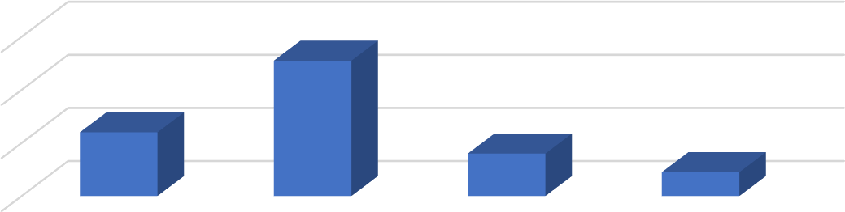

NO. OF RESPONSES

60

40

20

0

REGULARLY

OCCASIONALLY

RARELY

NEVER

**FIGURE 3.17**

**PERSONALIZED LEARNING RECOMMENDATION**

**TABLE 3.18**

**KANJIRAKADANS ACADAMY vs TRADITIONAL METHODS IN SUPPORTING INDIVIDUAL LEARNING**

|  |  |  |
| --- | --- | --- |
| **RESPONSES** | **NO. OF**  **RESPONDENTS** | **PERCENTAGE** |
| YES | 53 | 53 |
| NO | 47 | 47 |
| **TOTAL** | **100** | **100** |

**INTRPRETATION:**

The above table shows that 53% of respondents feel that Kanjirakadans Academy supports their individual needs more effectively than traditional methods, while 47% do not share this view.

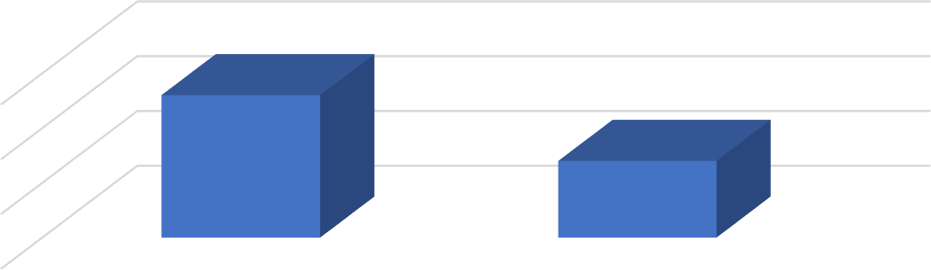

NO.OF RESPONSES

55

50

45

40

YES

NO

**FIGURE 3.18**

**KANJIRAKADANS ACADAMY vs TRADITIONAL METHODS IN SUPPORTING INDIVIDUAL LEARNING**

**TABLE 3.19**

**PERSONALIZED LEARNING RECOMMENDATION BASED ON PROGRESS**

|  |  |  |
| --- | --- | --- |
| **RESPONSES** | **NO OF RESPONDENTS** | **PERCENTAGE** |
| EXTRA HELP AND RESOURCES | 20 | 20 |
| LEARN AT MY OWN PACE | 46 | 46 |
| TARGETED EXCERCISES FOR PRACTICES | 28 | 28 |
| NOT HELP | 6 | 6 |
| **TOTAL** | **100** | **100** |

**INTERPRETATION:**

The table above shows that 46% of respondents feel personalized learning allows them to learn at their own pace with difficult subjects, 28% believe it offers targeted exercises for practice, 20% find that it provides extra help and resources, and 6% do not find any benefits.

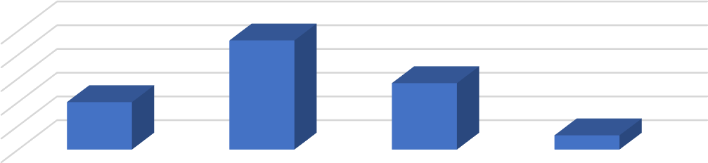

NO OF RESPONDENTS

50

40

30

20

10

0

EXTRA HELP AND LEARN AT MY OWN

RESOURCES PACE

TARGETED

EXCERCISES FOR PRACTICES

NOT HELP

**FIGURE 3.19**

**PERSONALIZED LEARNING RECOMMENDATION BASED ON PROGRESS**

**TABLE 3.20**

**INFLUENCE OF FEE STRUCTURE ON SELECTION**

|  |  |  |
| --- | --- | --- |
| **RESPONSES** | **NO. OF**  **RESPONDENTS** | **PERCENTAGE** |
| YES | 55 | 55 |
| NO | 45 | 45 |
| **TOTAL** | **100** | **100** |

**INTERPRETATION:**

The above table shows that 55% of respondents’ decision in choosing the institution is their fee structure & 45% does not.

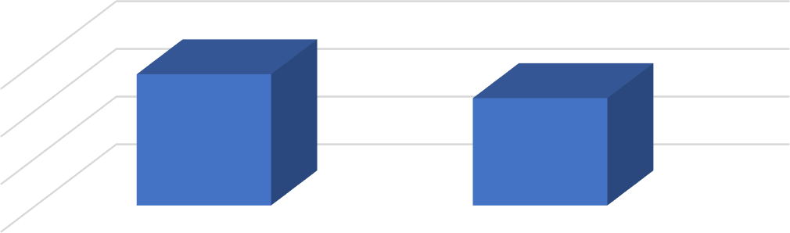

NO. OF RESPONDENTS

60

40

20

0

YES

NO

**FIGURE 3.20**

**INFLUENCE OF FEE STRUCTURE ON SELECTION**

**TABLE 3.21**

**IMPORTANCE OF LOCATION IN CHOOSING AN INSTITUTION**

|  |  |  |
| --- | --- | --- |
| **RESPONSES** | **NO. OF**  **RESPONDENTS** | **PERCENTAGE** |
| IMPORTANT | 22 | 22 |
| NEUTRAL | 60 | 60 |
| NOT IMPORTANT | 18 | 18 |
| **TOTAL** | **100** | **100** |

**INTERPRETATION:**

The above table shows that 60% of respondents find that location is a neutral factor in selecting an education institution, 22% of respondents believes as an important factor while 18% does not.

**FIGURE 3.21**

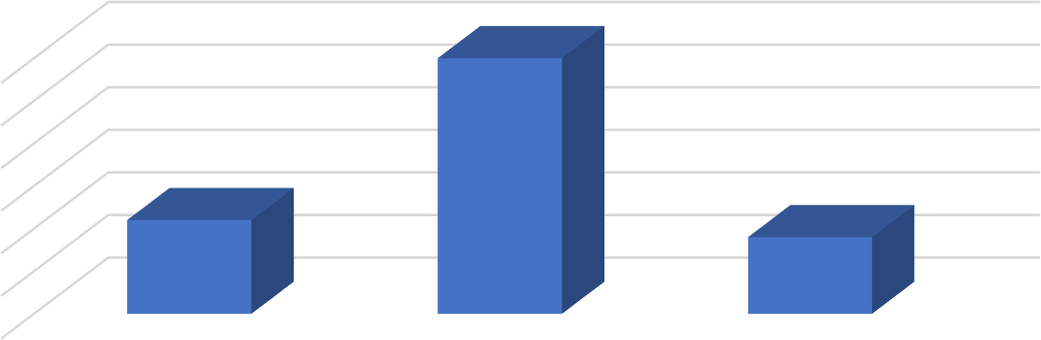**IMPORTANCE OF LOCATION IN CHOOSING AN INSTITUTION**

NO. OF RESPONDENTS

|  |  |  |  |
| --- | --- | --- | --- |
| 60 |  | | |
| 50 |  |  |  |
| 40 |  |  |  |
| 30 |  |  |  |
| 20 |  |  |  |
| 10 |  |  |  |
| 0 | IMPORTANT | NEUTRAL | NOT IMPORTANT |

**TABLE 3.22**

**SIGNIFICANCE OF FACULTY EXPERTISE IN CHOOSING AN INSTITUTION**

|  |  |  |
| --- | --- | --- |
| **RESPONSES** | **NO. OF RESPONDENTS** | **PERCENTAGE** |
| VERY SIGNIFICANT | 58 | 58 |
| NEUTRAL | 26 | 26 |
| NOT SIGNIFICANT | 16 | 16 |
| **TOTAL** | **100** | **100** |

**INTERPRETATION:**

The table above shows that 26% of respondents consider faculty expertise to be neutrally significant in their choice of institution, 58% believe it is important, and 16% do not find it significant.

**FIGURE 3.22**

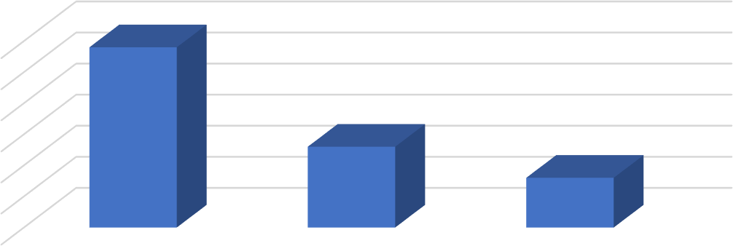**SIGNIFICANCE OF FACULTY EXPERTISE IN CHOOSING AN INSTITUTION**

NO.OF RESPONDENTS

|  |  |  |  |
| --- | --- | --- | --- |
| 60 |  | | |
| 50 |  |  |  |
| 40 |  |  |  |
| 30 |  |  |  |
| 20 |  |  |  |
| 10 |  |  |  |
| 0 | VERY SIGNIFICANT | NEUTRAL | NOT SIGNIFICANT |

**TABLE 3.23**

**INFLUENCE OF PERSONALIZED LEARNING OPTIONS ON INSTITUTION CHOICE**

|  |  |  |
| --- | --- | --- |
| **RESPONSES** | **NO. OF RESPONDENTS** | **PERCENTAGE** |
| STRONGLY INFLUENCE | 22 | 22 |
| NEUTRAL | 63 | 63 |
| NOT INFLUENCE | 15 | 15 |
| **TOTAL** | **100** | **100** |

**INTERPRETATION:**

The above table shows that 63% of respondents consider availability of personalized learning options influence their choice of an institution neutrally, 22% finds it strongly influence & 15% does not.

**FIGURE 3.23**

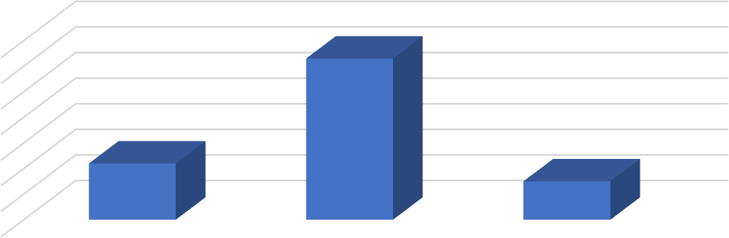**INFLUENCE OF PERSONALIZED LEARNING OPTIONS ON INSTITUTION CHOICE**

NO.OF RESPONDENTS

|  |  |  |  |
| --- | --- | --- | --- |
| 70 |  | | |
| 60 |  |  |  |
| 50 |  |  |  |
| 40 |  |  |  |
| 30 |  |  |  |
| 20 |  |  |  |
| 10 |  |  |  |
| 0 | STRONGLY INFLUENCE | NEUTRAL | NOT INFLUENCE |

**TABLE 3.24**

**FACTORS INFLUENCE IN CHOOSING KANJIRAKADANS ACADEMY**

|  |  |  |
| --- | --- | --- |
| **RESPONSES** | **NO. OF RESPONDENTS** | **PERCENTAGE** |
| QUALITY | 18 | 18 |
| REPUTATION | 45 | 45 |
| LOCATION AND ACCESSIBILITY | 30 | 30 |
| COST | 8 | 8 |
| **TOTAL** | **100** | **100** |

**INTERPRETATION:**

The above table shows that 45% of respondents key factor in choosing Kanjirakadans Academy is reputation of the institution, 30% says location and accessibility, 18% says quality of personalized learning & 8% says it cost of education.

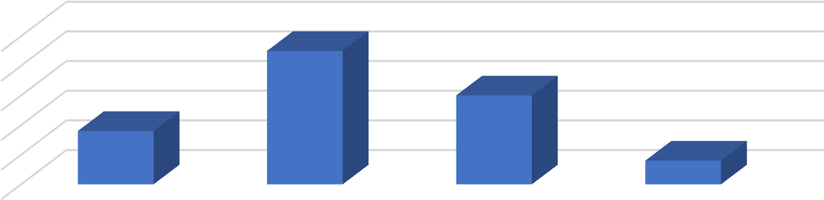

NO.OF RESPONDENTS

50

40

30

20

10

0

QUALITY

REPUTATION

LOCATION AND

ACCESSIBILITY

COST

**FIGURE 3.24**

**FACTORS INFLUECE IN CHOOSING KANJIRAKADANS ACADEMY**

**TABLE 3.25**

**TECHNICAL CHALLENGES IN PERSONALIZED LEARNING SESSIONS**

|  |  |  |
| --- | --- | --- |
| **RESPONSES** | **NO. OF**  **RESPONDENTS** | **PERCENTAGE** |
| FREQUENTLY | 28 | 28 |
| OCCASIONALLY | 43 | 43 |
| RARELY | 26 | 26 |
| NEVER | 3 | 3 |
| **TOTAL** | **100** | **100** |

## INTERPRETATION:

The above table shows that 43% of respondents occasionally face technical issues during personalized learning sessions, 28% face frequently, 26% face rarely & 3% never face any issues.

**FIGURE 3.25**

**TECHNICAL CHALLENGES IN PERSONALIZED LEARNING SESSIONS**

NO. OF RESPONDENTS

|  |  |  |  |  |
| --- | --- | --- | --- | --- |
| 50 |  | | | |
| 40 |  |  |  |  |
| 30 |  |  |  |  |
| 20 |  |  |  |  |
| 10 |  |  |  |  |
| 0 | FREQUENTLY | OCCASIONALLY | RARELY | NEVER |

**TABLE 3.26**

**LACK OF CLEAR GUIDANCE IN PERSONALIZED LEARNING SESSIONS**

|  |  |  |
| --- | --- | --- |
| **RESPONSES** | **NO. OF RESPONDENTS** | **PERCENTAGE** |
| YES | 42 | 42 |
| NO | 58 | 58 |
| **TOTAL** | **100** | **100** |

**INTERPRETATION:**

The above table above shows that 42% of respondents feel that there is a lack of clear guidance during personalized learning, while 58% do not share this concern.

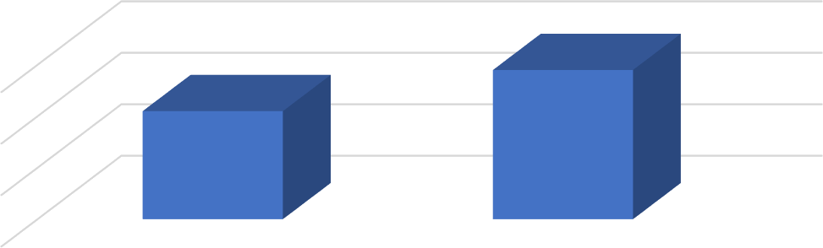

NO.OF RESPONDENTS

60

40

20

0

YES

NO

**FIGURE 3.26**

**LACK OG CLEAR GUIDANCE IN PERSONALIZED LEARNING SESSIONS**

**TABLE 3.27**

**INSUFFICIENT INSTRUTOR FEEDBACK IN PERSONALIZED LEARNING**

|  |  |  |
| --- | --- | --- |
| **RESPONSES** | **NO. OF**  **RESPONDENTS** | **PERCENTAGE** |
| YES | 8 | 8 |
| RARELY | 16 | 16 |
| VERY OFTEN | 23 | 23 |
| NEVER | 53 | 53 |
| **TOTAL** | **100** | **100** |

**INTERPRETATION:**

The table above shows that 23% of respondents feel that personalized learning often lacks feedback from instructors, 16% feel it rarely, 8% feels it, and 53% feel it never.

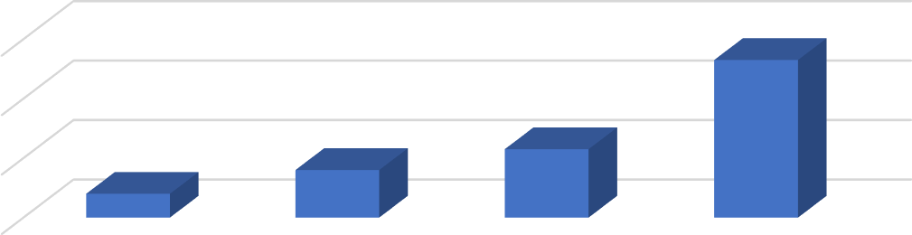

NO. OF RESPONDENTS

60

40

20

0

YES

RARELY

VERY OFTEN

NEVER

**FIGURE 3.27**

**INSUFFICIENT INSTRUTOR FEEDBACK IN PERSONALIZED LEARNING**

**TABLE 3.28 WORKLOAD COMPARISON**

|  |  |  |
| --- | --- | --- |
| **RESPONSES** | **NO. OF RESPONDENTS** | **PERCENTAGE** |
| YES, SIGNIFICANTLY | 20 | 20 |
| NEUTRAL | 18 | 18 |
| NO, WORK LOAD IS SIMILAR | 62 | 62 |
| **TOTAL** | **100** | **100** |

**INTERPRETATION:**

The above table shows that 20% of respondents feels that personalized learning significantly creates more workload compared to traditional learning methods, 18% neutrally & 62% feels similar workload

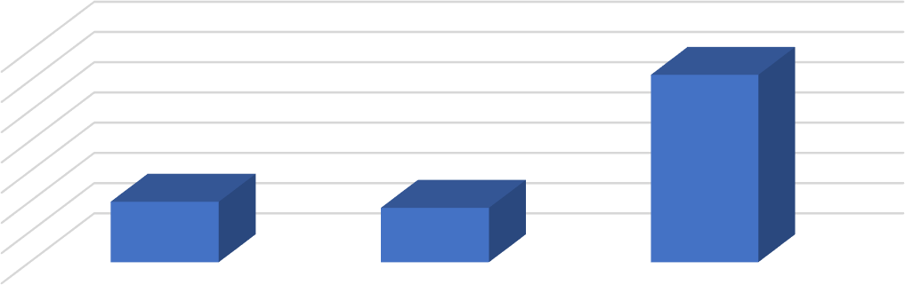

NO.OF RESPONDENTS

70

60

50

40

30

20

10

0

YES, SIGNIFICANTLY

NEUTRAL

NO, WORK LOAD IS

SIMILAR

**FIGURE 3.28 WORKLOAD COMPARISON**

**TABLE 3.29**

**DIFFICULTY IN BALANCING COMMITMENTS**

|  |  |  |
| --- | --- | --- |
| **RESPONSES** | **NO. OF**  **RESPONDENTS** | **PERCENTAGE** |
| YES | 10 | 10 |
| SOMETIMES | 23 | 23 |
| VERY OFTEN | 16 | 16 |
| NEVER | 51 | 51 |
| **TOTAL** | **100** | **100** |

## INTERPRETATION:

The above table shows that 23% of respondents sometimes experience difficulties in managing the personalized learning schedule along with other commitments, 16% oftenly, 10% experienced & 51% never experience

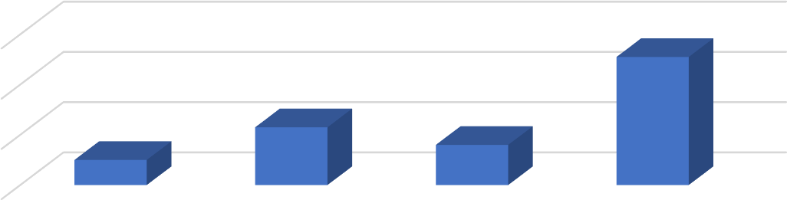

NO. OF RESPONDENTS

60

40

20

0

YES

SOMETIMES

VERY OFTEN

NEVER

**FIGURE 3.29**

**DIFFICULTY IN BALANCING COMMITMENTS**

# CHAPTER 4 RESULTS

**FINDINGS**

* The study found that majority of respondents are male (52%).
* Most respondents are in the age group of 20-25 (39%)
* Respondents are predominantly undergraduate students
* The majority of respondents belong to families earning ₹35,000-45,000 (42%)
* The majority pf the respondents use educational networks occasionally
* Specialized learning websites (35%) are the most used education networks.
* Most of the respondents prefer learning through educational networks over traditional methods.
* AI-generated responses (37%) and search engines (35%) are the most valued features of educational networks.
* 57% find personalized sessions are more engaging than traditional classes
* 54% report excellent understanding after personalized learning
* 68% of respondents believe personalized learning has improved their exam performance.
* Majority of respondents feel personalized learning reduces their academic stress.
* 51% of respondents find the learning pace mostly meets their needs at Kanjirakadans Academy
* 53% believe the academy supports individual needs better than traditional methods.
* Fee structure influences 55% of respondents in choosing the institution.
* Faculty expertise is important for 58% of respondents while choosing an institution.
* Reputation (45%) and location/accessibility (30%) are key factors for choosing Kanjirakadans Academy,
* 62% of respondents believe personalized learning creates a workload similar to traditional methods.
* Least number of respondents (23%) sometimes face difficulties managing personalized learning schedules alongside commitments.

# SUGGESTIONS

* Fee structures and financial aid programs could be tailored to accommodate students from lower-income brackets, enhancing accessibility.
* Regular feedback mechanisms can identify gaps and improve resource quality, ensuring higher satisfaction levels.
* Making sessions more interactive and including peer learning opportunities could boost engagement levels.
* Stress management workshops and flexible schedules could enhance the perceived benefits of personalized learning.
* Implementing regular feedback systems and customized action plans could improve perceived effectiveness.
* Providing planning tools and flexible learning hours can help learners manage their schedules more effectively.
* Providing planning tools and flexible learning hours can help learners manage their schedules more effectively

# CONCLUSION

The study highlights the effectiveness of personalized learning at Kanjirakadans Academy in meeting the diverse needs of learners. While the approach has demonstrated significant benefits in improving engagement, understanding, and academic performance, there are areas requiring further enhancement, such as consistent personalized support, clear guidance, and technical infrastructure. The findings underline the importance of tailored learning solutions, the role of technology, and the academy’s commitment to offering flexible and student-centered education. With targeted improvements, personalized learning can become even more impactful, fostering better outcomes and satisfaction among learners.

Data for this research was gathered through questionnaires distributed among students, with percentage-based analysis providing key insights. The findings emphasize the effectiveness of personalized learning while identifying areas such as consistent learner support, enhanced feedback mechanisms, and better integration of technology as opportunities for improvement.

# BIBILOGRAPHY

**REFERENCE**

* Kothari, C R, Research Methodology: Methods and Techniques, New Delhi, New Age International, (2004)
* Flippo B Edwin, Personnel Management, Sixth Edition, New York, McGraw Hill Book Company (2007)

**WEBSITE**

* [**https://en.wikipedia.org/wiki/Education**](https://en.wikipedia.org/wiki/Education)
* [**https://chatgpt.com**](https://chatgpt.com/)
* [**https://kanjirakadansacademy.in/**](https://kanjirakadansacademy.in/)

# ANNEXURE

**QUESTIONNAIRE**

**BASIC INFORMATION**

1. Name:
2. Gender:
   1. Male
   2. Female
3. Age:
   1. 15-20
   2. 21-25
   3. 26-30
   4. 30 above
4. Educational status:
   1. 10th grade
   2. 12th grade
   3. Undergraduate
   4. Postgraduate
5. Family income:
   1. Below 25000
   2. 25000-35000
   3. 35000-45000
   4. 45000 above
6. How often do you use education networks for learning purposes?
   1. Daily
   2. Weekly
   3. Occasionally
   4. Rarely
7. How satisfied are you with resources provided by the education networks?
   1. Very satisfied
   2. Neutral
   3. Dissatisfied
8. Which of the following education network do you use most frequently for personalized learning?
   1. YouTube
   2. Search engines (e.g., Google)
   3. Specialized learning websites
   4. AI tools (e.g., Chat GPT)
9. Which education network feature do you find most valuable for personalized learning?
   1. Video tutorials
   2. Search options
   3. AI-generated operations
   4. Interactive learning tools
10. Do you prefer learning through educational networks compared to traditional classroom methods?
    1. Yes
    2. No
11. Do you find personalized learning sessions more engaging than traditional classes?
    1. Yes
    2. No
12. How well do you understand the topics after personalized learning?
    1. Extremely well
    2. Neutral
    3. Not at all
13. Do you think personalized learning has helped you perform better in exams?
    1. Yes
    2. No
14. Does personalised learning reduce the stress associated with academics?
    1. Yes
    2. No
15. How often do you receive personalized learning support at Kanjirakadans academy?
    1. Always
    2. Often
    3. Sometimes
    4. Never
16. Do you receive enough individual attention during personalized learning sessions?
    1. Yes
    2. No
17. Do you feel that the learning pace at Kanjirakadans Academy is suited to your needs?
    1. Yes, it is perfect
    2. It’s mostly good
    3. Sometimes it’s too fast or slow
    4. No, it does not suit my needs
18. Do you receive personalized learning recommendations based on your progress?
    1. Regularly
    2. Occasionally
    3. Rarely
    4. Never
19. Do you feel that Kanjirakadans Academy supports your individual learning needs more effectively than traditional methods?
    1. Yes
    2. No
20. How does personalized learning help you with difficult subjects?
    1. It provides extra help and resources
    2. It allows me to learn at my own space
    3. It offers targeted exercises for practices
    4. It does not help with difficult subjects
21. Does the institution’s fee structure influence your decision to choose it?
    1. Yes
    2. No
22. How important is location in selecting an education institution?
    1. Extremely important
    2. Neutral
    3. Not important
23. How significant is the faculty’s expertise in your choice of institution?
    1. Very significant
    2. Neutral
    3. Not significant
24. How much does the availability of personalized learning options influence your choice of an institution?
    1. Strongly influence
    2. Neutral
    3. Not influence
25. What influenced you the most in choosing Kanjirakadans Academy?
    1. Quality of personalised learning
    2. Reputation of the institution
    3. Location and accessibility
    4. Cost of education
26. Do you face any technical issues during personalized learning sessions?
    1. Frequently
    2. Occasionally
    3. Rarely
    4. Never
27. Is there any lack of clear guidance during personalized learning?
    1. Yes
    2. No
28. Do you feel that personalized learning lacks adequate feedback from instructors?
    1. Yes
    2. Rarely
    3. Very often
    4. Never
29. Do you feel that personalized learning creates more workload compared to traditional learning methods?
    1. Yes, significantly more
    2. Neutral
    3. No, workload is similar
30. Do you experience difficulties in managing the personalized learning schedule along with other academic or personal commitments?
    1. Yes
    2. Sometimes
    3. Very often
    4. Never